Project Planning Phase
Project Planning Template (Product Backlog, Sprint Planning, Stories, Story Points)
Date | 14 July 2026
Team ID | SWTID-2026-5258
Project Name | India's Agricultural Crop Production Analysis (1997-2021)
Maximum Marks | 5 Marks

Project Overview
Project Title
India's Agricultural Crop Production Analysis (1997-2021)
Internship
Data Analytics with Tableau
College
Sri Venkateswara College of Engineering, Tirupati
Department
Artificial Intelligence and Machine Learning
Team Members
Team Member | Role
Shaik Imamkhasim | Team Lead
Balaji Veligandla | Member
Varada Veera Manoj | Member

Project Summary
The project analyzes India's Agricultural Crop Production dataset from 1997 to 2021 using Tableau Public. The dataset includes the fields State, District, Crop, Season, Year, Area, Production, and Yield. The dashboard includes Total Production and Total Yield KPIs, an India map, an agricultural yield trend line chart, year-wise production and state-wise cultivated area bar charts, a production distribution donut chart, a leading agricultural states pie chart, and season-wise production visuals. The dashboard supports interactive dashboard actions, so that selecting one visualization updates all remaining visualizations.

Product Backlog, Sprint Schedule, and Estimation (4 Marks)
Use the below template to create the product backlog and sprint schedule.
Sprint | Functional Requirement (Epic) | User Story Number | User Story / Task | Story Points | Priority | Team Members
Sprint-1 | Project Planning | USN-1 | As a team, we can create a project charter defining the scope, objectives, and timeline of the Tableau dashboard project. | 4 | High | Shaik Imamkhasim
Sprint-1 | Requirement Analysis | USN-2 | As a team lead, I can gather dashboard requirements from mentors so that the KPIs and visualizations to be built are clearly defined. | 4 | High | Shaik Imamkhasim
Sprint-1 | Dataset Collection | USN-3 | As a data analyst, I can download the India Agricultural Crop Production dataset (1997-2021) from the government open data portal. | 4 | High | Balaji Veligandla
Sprint-1 | Dataset Collection | USN-4 | As a data analyst, I can verify that the dataset contains all required fields (State, District, Crop, Season, Year, Area, Production, Yield) and store it in a shared drive. | 4 | Medium | Balaji Veligandla
Sprint-1 | Tableau Data Connection | USN-5 | As a developer, I can connect the cleaned dataset to Tableau Public so that I can begin building visualizations. | 4 | High | Varada Veera Manoj
Sprint-2 | Data Cleaning | USN-6 | As a data analyst, I can remove duplicate and null records and standardize State/District names so that the map visualization renders correctly. | 4 | High | Balaji Veligandla
Sprint-2 | KPI Creation | USN-7 | As a developer, I can create Total Production and Total Yield KPI cards that update dynamically with the applied filters. | 4 | High | Varada Veera Manoj
Sprint-2 | India Map / Line Chart | USN-8 | As a developer, I can build a filled India map for state-wise production and a line chart showing the agricultural yield trend. | 4 | High | Shaik Imamkhasim
Sprint-2 | Bar Charts | USN-9 | As a developer, I can build bar charts showing year-wise production and state-wise cultivated area. | 4 | High | Varada Veera Manoj
Sprint-2 | Donut Chart / Pie Chart / Dashboard Design | USN-10 | As a developer, I can build a donut chart for production distribution and a pie chart for leading agricultural states, and arrange all visuals into one dashboard layout. | 4 | Medium | Varada Veera Manoj
Sprint-3 | Interactive Filters | USN-11 | As a user, I can filter the dashboard by State, Year, and Season so that I can compare production across regions and time periods. | 4 | High | Varada Veera Manoj
Sprint-3 | Interactive Filters | USN-12 | As a user, I can click on a state in the India map so that all other visualizations update automatically to show that state's data. | 4 | High | Shaik Imamkhasim
Sprint-3 | Story Creation | USN-13 | As a developer, I can create a Tableau story that walks through the key insights from the crop production analysis. | 4 | Medium | Shaik Imamkhasim
Sprint-3 | Dashboard Testing | USN-14 | As a tester, I can verify that all dashboard actions and filters work correctly across every visualization. | 4 | High | Balaji Veligandla
Sprint-3 | Dashboard Testing | USN-15 | As a tester, I can validate that KPI values match manually calculated totals from the dataset and check the dashboard on different screen sizes. | 4 | High | Balaji Veligandla
Sprint-4 | Tableau Public Publishing | USN-16 | As a developer, I can publish the completed dashboard to Tableau Public so that it is accessible online. | 4 | High | Shaik Imamkhasim
Sprint-4 | GitHub Repository | USN-17 | As a developer, I can create a GitHub repository and upload the project files, dataset link, README, and published dashboard link. | 4 | Medium | Varada Veera Manoj
Sprint-4 | Documentation | USN-18 | As a documenter, I can prepare a project report describing the dataset, methodology, and dashboard components with screenshots. | 4 | High | Balaji Veligandla
Sprint-4 | Documentation | USN-19 | As a documenter, I can write user instructions explaining how to interact with the dashboard filters and actions. | 4 | Medium | Balaji Veligandla
Sprint-4 | Final Presentation | USN-20 | As a team, we can prepare and rehearse presentation slides summarizing the project goals, dashboard, and key insights for the final review. | 4 | High | Shaik Imamkhasim

Project Tracker, Velocity & Burndown Chart (4 Marks)

Velocity
Team velocity is the average number of story points a team completes per sprint. Across the four sprints, the team completed 20 story points in each 6-day sprint, giving a consistent sprint velocity of 20 points/sprint.
Average Velocity (AV) = Story Points Completed / Sprint Duration = 20 / 6 = 3.33 story points per day
Average Sprint Velocity = (20 + 20 + 20 + 20) / 4 sprints = 20 story points per sprint. This steady velocity shows the team estimated story points realistically and maintained a consistent pace across dataset preparation, dashboard development, testing, and publishing.

Burndown Chart
A burndown chart is a graphical representation of work remaining versus time. It is commonly used in Agile methodologies such as Scrum to track whether a team is on pace to complete the sprint backlog. The table and chart below show the ideal versus actual burndown for Sprint-1 (20 story points over a 6-day sprint).
Sprint Day | Ideal Remaining Story Points | Actual Remaining Story Points
Day 0 (Start) | 20 | 20
Day 1 | 16.7 | 17
Day 2 | 13.3 | 14
Day 3 | 10.0 | 10
Day 4 | 6.7 | 7
Day 5 | 3.3 | 3
Day 6 (End) | 0 | 0
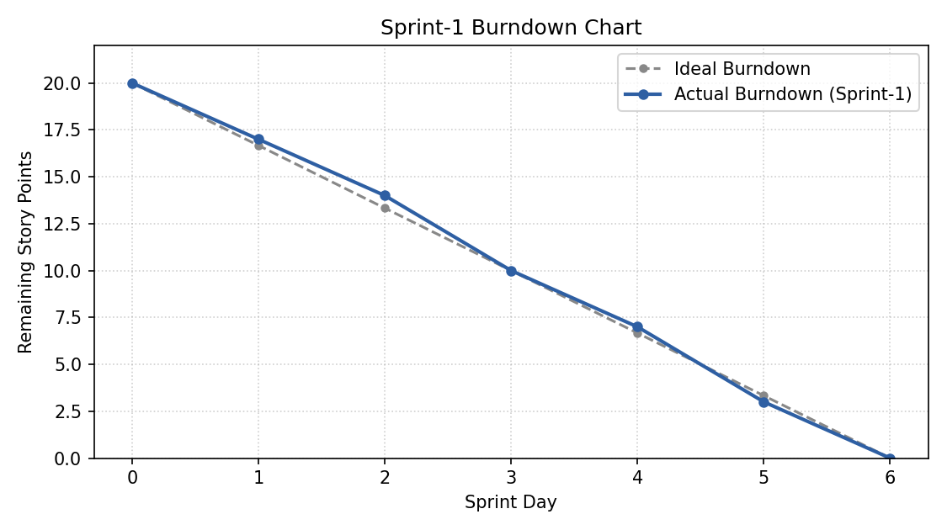
The actual burndown line closely tracks the ideal line, with a small backlog on Day 1-2 (during dataset cleaning) fully recovered by Day 3, confirming the sprint was completed on schedule.

